Create your Patient Access Account

Dear Patient,

Thank you for completing the online access form and providing your proof of identity documentation. Please note that when you complete the online registration below the website will advise you that you need to bring in proof if ID – you have already done this so do not need to do this again. Please follow these instructions carefully when registering.
- You can now register for the new online service using this link - https://app.patientaccess.com/registration
- Enter your personal details. Note: The gender field is optional.
- Enter your account details. Note: The Mobile phone and Marketing fields are optional.
- Accept the terms and conditions.
- Select Create account.
- Next you need to link your practice
  - Select Link Your GP Practice - enter the practice postcode PL12 5LH (it won’t find it by name)
  - Select Search
  - Select QUAY LANE SURGERY from the list (do not select DOWNDERRY as it won’t link)
  - Select Continue
- Below the question 'Have you received a registration letter from your practice?' select NO (if you select YES then you will be asked for a linkage code. Please contact the surgery for this code)
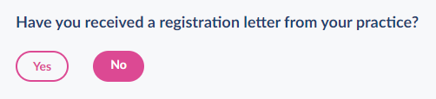
- Read the information messages on-screen then select Continue.
- Check your personal details and enter either your house number, flat number or street number, then select Continue (do not type in your full address)
Note: The personal details must match the details held by your practice.
- Confirm (enter) your enter your password again, then select Link Account.
- On the confirmation screen, select Done.
You will get a message informing you your account has been created and you are limited to booking a single appointment. Please allow up to one week for your account to be properly activated by the surgery after you have completed the above online registration.

When you first log in the Patient Access team recommend that you follow the detail in this link to verify the email you have used to create your account: https://support.patientaccess.com/your-profile/verify-contact-details You will receive an email with a link that you can click to verify your email and telephone number – this is essential as without this verification you will not be able to reset your password if you experience any password issues and your account will become locked (we cannot unlock it for you).

We would like to thank you for your patience whilst we have been getting the system working for you.

Quay Lane Surgery

